**Task1 : Install Chocolatey**

1. Open Power shell as administrator and run the below command.

**Get-ExecutionPolicy**

1. Run below command to install.

Set-ExecutionPolicy Bypass -Scope Process -Force; [System.Net.ServicePointManager]::SecurityProtocol = [System.Net.ServicePointManager]::SecurityProtocol -bor 3072; iex ((New-Object System.Net.WebClient).DownloadString('https://community.chocolatey.org/install.ps1'))

**Task 2 : Install helm**

1. Oen Power shell as administrator and run below command to install Helm.

**choco install kubernetes-helm**

**Task 3 : Install Python**

[Download Python | Python.org](https://www.python.org/downloads/)

1. Select Add Python.exe to the PATH and then click on Install.

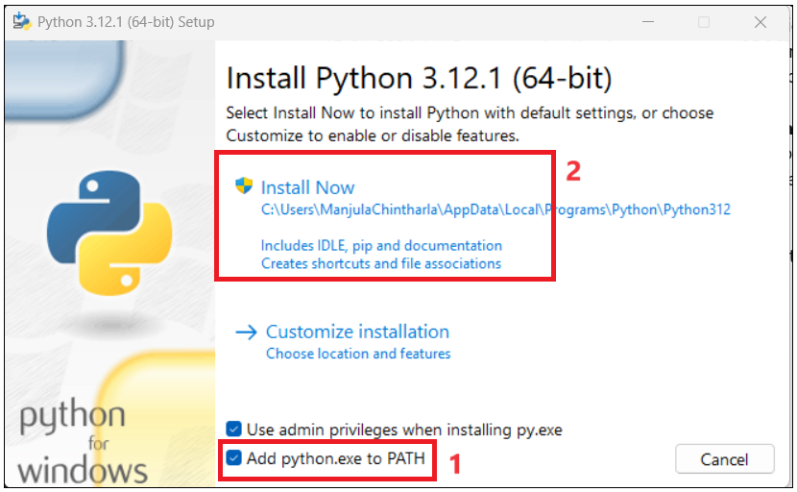

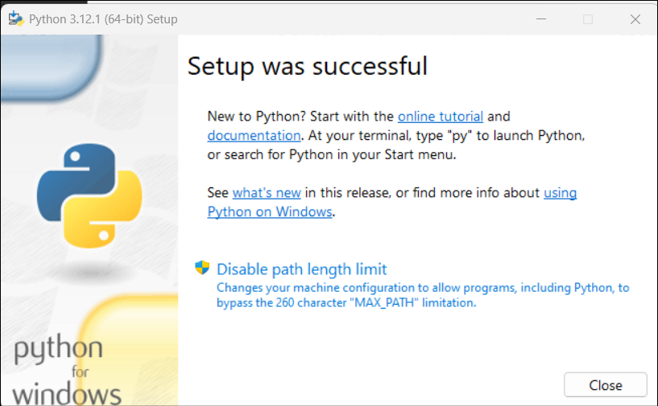

**Task 4 : Install .NET SDK 8.**

[Download .NET 8.0 (Linux, macOS, and Windows) (microsoft.com)](https://dotnet.microsoft.com/en-us/download/dotnet/8.0)

* 1. Follow instructions and install .

**Task 5 : Install Node JS.**

[Node.js — Download (nodejs.org)](https://nodejs.org/en/download)

* 1. Click on Next.

* 1. Accept the terms and click on Next.

* 1. Keep the default location and click Next.

* 1. Click Next

* 1. Select the checkbox and then click Next.

* 1. Click on Install.

* 1. After installation ,click Finish.

**Task 6 : Install Visual Studio Code.**

[Visual Studio Code - Microsoft Apps](https://apps.microsoft.com/detail/xp9khm4bk9fz7q?launch=true&mode=full&hl=en-us&gl=in&ocid=bingwebsearch)

1. Accept the agreement and then click on **Next**.

1. Keep the default location and then click on Next.

1. Click Next again.

1. Select Create a desktop icon creation checl box and then click on Next.

1. Click on **Install** now.

1. Click on Finish.

### Task 8 : Install GitGit

1. Download and install from [git-scm.com/downloads](https://git-scm.com/downloads).
2. Follow the instructions to install it.

### Task 9 : Azure CLI

* + 1. Download Azure-cli.exe file.

[Install the Azure CLI for Windows | Microsoft Learn](https://learn.microsoft.com/en-us/cli/azure/install-azure-cli-windows?tabs=azure-cli)

* + 1. Follow installation instructions and complete installation.